
Real-Time Distributed Analytics Dashboard Project

Prepared by:
Salah Zaid Salah Qaraeen : 2200901042
Mohammad Amjad Khalil Almasri : 2250901005
Mohammad Dahod Abdalrzaq Alkhateeb : 2200901104

Supervisor:
Dr. Khaled Batiha

Submitted in Partial Fulfillment of the Requirements for the Bachelor's Degree
in computer Science

Prince Al Hussein bin Abdullah Faculty of Information Technology
Al al Bayt University

Al Mafraq – Jordan
2025/2026

Table of contents
Acknowledgment
Declaration
CHAPTER1: INTRODUCTION

Project overview

Problem statement

Objectives

System advantages
CHAPTER 2 : RELATED WORK
- Existing analytics dashboards
- Limitations of current solutions
- Motivation for proposed system
CHAPTER 3 :SYSTEM DESIGN
- System architecture
- Database design
- Data flow
- Api design
CHAPTER 4 : IMPLEMENTATION & TESTING
- Technologies used
- Code structure
- Key implementation
- Testing strategy
CHAPTER 5 :FUTURE WORK
REFERENCES

Acknowledgment

We extend our sincere thanks and deep appreciation to Dr. Khaled Batiha for his continuous support throughout our graduation project and his constant dedication to providing guidance and advice. His clear approach in simplifying and explaining concepts had a significant impact on helping us understand various topics and overcome challenges.
We truly value his patience, dedication, and commitment to helping us achieve the best possible results. His support was a source of inspiration and encouragement throughout this journey.
We would also like to express our heartfelt gratitude to our families, friends, and everyone who offered us support and assistance during this important stage of our academic journey.

Declaration
We hereby declare that this graduation project is our original work and has not been submitted previously for any degree or qualification at any other institution. All sources of information used in this project have been properly acknowledged and referenced. We take full responsibility for the content of this project.
Names : Salah Qaraeen, Mohammad Almasri, Mohammad Alkhateeb
Student number : 2200901042, 2250901005, 2200901104

CHAPTER1: INTRODUCTION

1.1 Project overview :
The rapid growth of the internet has led to an increase in web development projects. Small and medium-sized websites often face challenges in reaching users and remaining competitive in their respective markets. This project presents an analytics dashboard system that helps such websites grow by providing detailed insights into website traffic and user behavior. By analyzing this data, website owners can identify areas for improvement, optimize user experience, and make informed decisions to enhance overall performance and engagement.

1.2 Problem statement :
Many websites lack clear insights into user behavior, such as which products or services are most popular, where users are accessing the site from, and how different devices are being used. Without this information, website owners cannot make informed decisions to optimize user experience, support multiple regions, or increase their user base. This project aims to address these challenges by providing an analytics system that collects and analyzes website traffic and user interactions. The results will help website owners improve their sites, make them more responsive across devices, target different regions effectively, and ultimately enhance user engagement and satisfaction.

1.3 Objectives :
- To develop an analytics dashboard that collects and visualizes website traffic data in real time.
- To provide insights into user behavior, including most visited pages, popular products, and user locations.
- To improve website performance and user experience across multiple devices.
- To help website owners make informed decisions to increase user engagement and optimize resources.
- To enable data-driven decisions for targeting specific regions and expanding the user base.
1.4 System advantages :
- Decision Support: Transforms raw traffic data into clear insights for better strategic decisions.
- Efficiency: Saves time compared to manual analysis of web data.
- Usability: Offers intuitive dashboards for users with no technical background.
- Growth Potential: Helps website owners identify opportunities to attract more users and improve engagement.
- Scalability: Can be extended to include more features or support larger websites in the future.

CHAPTER 2 : RELATED WORK
2.1 Existing analytics dashboards
Several analytics dashboards are widely used to monitor website traffic and user behavior. Google Analytics is the most popular tool, offering features such as real-time tracking of users, page views, clicks, form submissions, and session statistics. It also provides insights into device type, browser, geographic location, and user behavior patterns. Umami is an open-source, privacy-focused alternative that collects similar metrics but emphasizes simplicity and user privacy. Other platforms, such as Matomo and Open Web Analytics, offer comparable tracking features but may require more technical setup or hosting. These dashboards demonstrate the importance of collecting data to improve website performance and user experience.
2.2 Limitations of current solutions
While existing dashboards provide many useful features, they also have limitations. Google Analytics, for instance, can be complex for small website owners and imposes restrictions in its free version. Umami is lightweight and privacy-friendly but lacks advanced real-time tracking and detailed e-commerce analytics. Other tools may require technical expertise, external hosting, or cannot provide aggregated metrics for different time intervals (e.g., 5 minutes, 1 hour, 1 day). Additionally, many dashboards do not provide a unified view of user interactions, device information, and e-commerce events in a single interface, making it difficult for website owners to make data-driven decisions efficiently.
3.2 Motivation for proposed system
These limitations motivate the development of a new analytics dashboard tailored for small to medium websites. The proposed system collects real-time data every 5 seconds, including user interactions, page views, and online users. It aggregates metrics over 5-minute, hourly, and daily intervals, offering insights such as user behavior patterns, popular pages, and e-commerce activity. The system also tracks device types, browser information, geographic location, and session duration to provide a complete view of website performance. By integrating these features into a single, easy-to-use dashboard, the system helps website owners make informed decisions, optimize the user experience across devices, and grow their user base effectively.

Table 2.1: Feature Comparison Between Analytics Dashboards
feature | Google analytics | umami | Proposed system
Real-time users | ✅ | ✅ | ✅
Page & session data | ✅ | ✅ | ✅
Device & browser info | ✅ | ✅ | ✅
User behavior | ✅ | ✅ | ✅
E-commerce events | ✅ | ❌ | ✅
Aggregated metrics (5m, 1h, 1d) | ✅ | ❌ | ✅
Privacy-friendly | ❌ | ✅ | ✅

CHAPTER 3 :SYSTEM DESIGN
2.1 Existing analytics dashboards
The proposed system is designed as a distributed real-time analytics platform that supports scalability, high availability, and efficient processing of large volumes of data. The architecture follows a layered approach, where each component has a clearly defined role within the system.
The system separates data collection, backend processing, and data visualization into independent components. This design allows each part of the system to scale independently and improves overall system maintainability and performance.
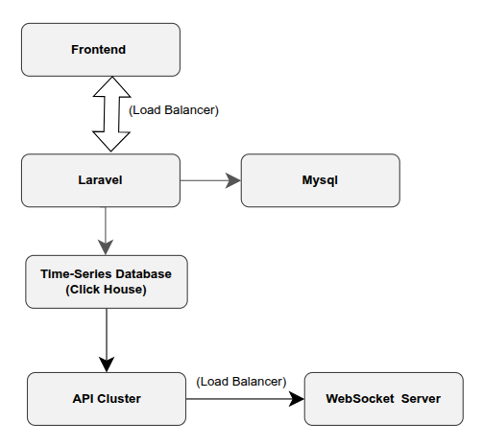
Figure 3.1 illustrates the overall system architecture of the proposed solution.

Architecture Components

Frontend Layer
The frontend layer represents the analytics dashboard used by administrators and website owners. It provides visualizations for real-time and historical analytics metrics. Communication with the backend is handled through secure WebSocket connections to support live updates after user authentication.

Backend Gateway (Authentication & WebSocket)
The backend gateway manages user authentication and authorization and acts as the main communication interface between the frontend and backend services. It validates user credentials, issues authentication tokens, and controls access to dashboard APIs. The gateway also maintains WebSocket connections with authenticated users to push real-time analytics updates securely.

Relational Database (MySQL – User Management & Validation)
The relational database (MySQL) is used by the authentication backend to store and manage user accounts. It handles user registration, login validation, password hashing, and role-based access control. MySQL ensures data consistency and security for transactional user-related operations and is used exclusively for user management.

Data Collectors
Data collectors are responsible for receiving analytics events generated by tracked websites through a lightweight JavaScript tracking script. This script is embedded into websites using a CDN-based source and runs in the browser to capture user interactions such as page views, clicks, and sessions.

Analytics Processing Backend (API Cluster & Kafka)
This component handles the processing of analytics events at scale. After initial validation, events are forwarded to a Kafka cluster for asynchronous processing. Kafka consumers process and prepare the data for storage. The API cluster provides scalable access to analytics data for reporting and dashboard visualization.

Time-Series Database (ClickHouse)
The time-series database stores analytics data efficiently and supports fast querying for time-based metrics. ClickHouse is used exclusively for storing raw analytics events and aggregated analytical data. It enables the system to generate insights across different time intervals such as 5 minutes, 1 hour, and 1 day.

Summary
The system architecture is designed to support real-time analytics through a distributed and modular design. By separating communication, processing, and storage responsibilities, the architecture ensures scalability, reliability, and maintainability.
3.2 Database design
The database layer is designed to support both user management and analytics processing. To achieve this, the system uses two separate databases:
- MySQL – stores user accounts and authentication data for the dashboard.
- ClickHouse – stores raw analytics events and pre-aggregated metrics.
This separation improves performance, simplifies analysis, and ensures data security by isolating transactional user data from high-volume analytics data.
User account data, including credentials and roles, is stored in MySQL, while ClickHouse stores only analytics data.
.

3.2.1 Base Tables (Raw Data Storage)
The base tables are responsible for storing raw analytics data collected directly from user interactions. These tables store high-frequency events that are inserted at short intervals (approximately every few seconds).
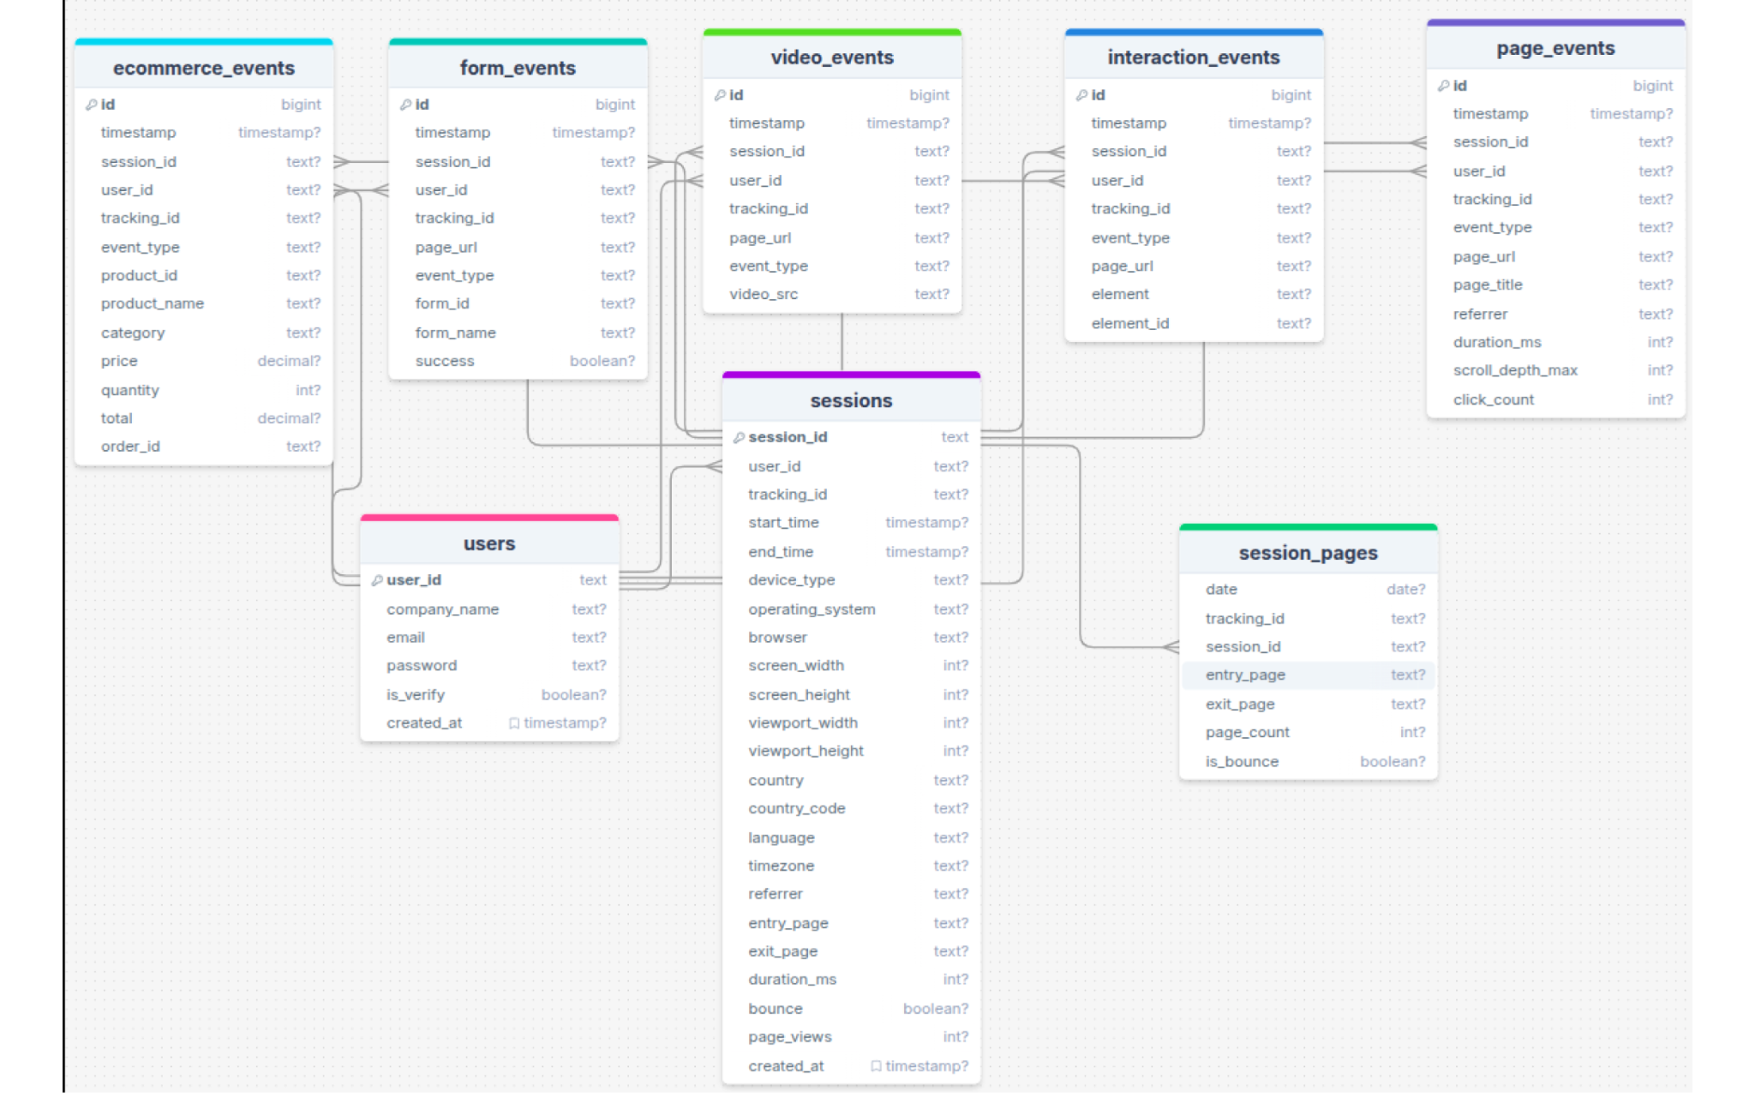
Figure 3.2: Entity Relationship Diagram (ERD) of Base Tables
Description:
- users stores registered system users.
- sessions records user sessions and device-related metadata.
- page_events captures page views and timing metrics.
- interaction_events stores user interaction events.
- form_events records form-related activities.
- ecommerce_events captures shopping-related events.
- video_events stores video interaction data.
- session_pages summarizes page navigation within a session.
MySQL Base Tables (User Management)
Table | Description
users | Stores registered users (name, email, hashed password, role, email_verified_at, remember_token).
password_resets | Handles password recovery requests.
personal_access_tokens | Stores JWT or API tokens for authentication.
email_verifications | Tracks email verification status for users.
Note: All user authentication, registration, and password validation operations interact only with MySQL. ClickHouse is not used for storing any sensitive user data.

3.2.2 Analytics Summary Tables (Materialized Analytics Layer)
To support efficient analytics and reporting, the system uses a second set of tables that store pre-aggregated analytics results. These tables represent the output of analytical processing and are updated periodically.
Analytics calculations are performed over multiple time intervals:
- Every 5 minutes
- Every 1 hour
- Every 1 day
The results of these calculations are stored in analytics summary tables rather than recalculated on every query. This approach significantly improves query performance and supports real-time dashboard updates.

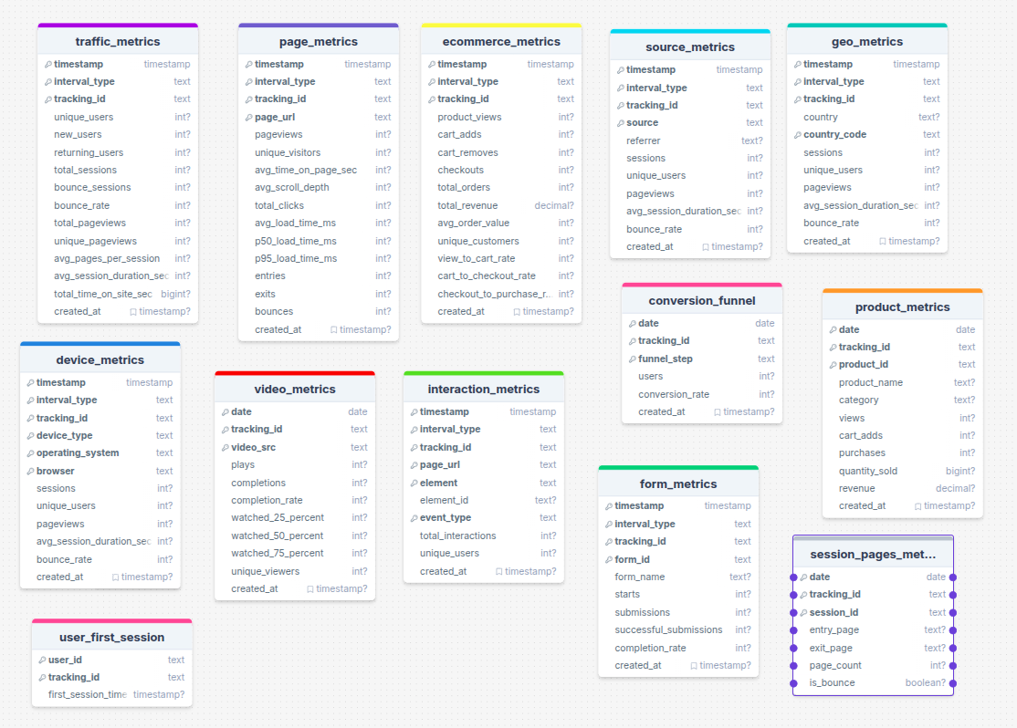
Figure 3.3: Analytics Summary Tables and Aggregation Intervals

Description:
- Traffic metrics summarize session and user behavior.
- Page metrics analyze page performance and engagement.
- Device, geo, and source metrics provide segmentation insights.
- Interaction and form metrics measure user engagement.
- E-commerce and product metrics track conversions and revenue.
- Video metrics analyze media engagement.
- Conversion funnel metrics represent user progression through key steps.

Summary
The database design follows a layered analytics approach by separating raw event storage from analytical results. Raw data is stored at high frequency, while analytics summary tables store aggregated results at fixed time intervals. This design ensures scalability, fast analytics queries, and flexibility for future extensions.
3.3 Data flow
This section explains how data moves through the system from the moment it is generated on a user’s website until it is stored, analyzed, and finally visualized on the analytics dashboard.
The data flow is divided into two main parts:
- Data Collection and Processing Flow
- Dashboard and Real-Time Visualization Flow
This separation improves clarity and reflects the distributed nature of the system.

3.3.1 Data Collection and Processing Flow
This flow describes how user interaction data is collected from client websites, validated, processed, and stored in the time-series database for further analysis. The process is designed to handle high traffic using distributed components and asynchronous processing.
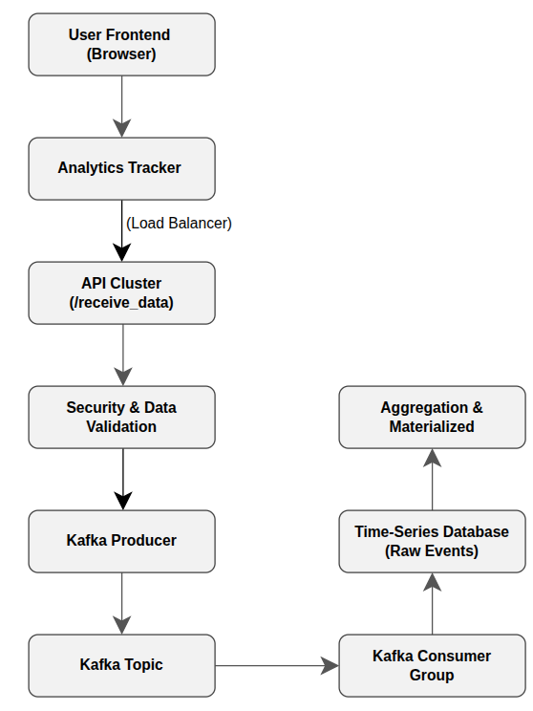
Client-Side Data Collection
A lightweight JavaScript tracking script is embedded in the client’s website. This script captures user interactions such as page views, clicks, sessions, and device information, and sends the data periodically to the backend.
API Cluster
Collected data is sent to a distributed API cluster through a dedicated endpoint. The cluster ensures scalability and fault tolerance when handling a large number of incoming requests.
Validation and Security
Before processing, incoming data is validated to ensure it originates from a registered tracking ID and follows the expected format. Invalid or suspicious data is rejected.
Kafka-Based Processing
After validation, events are published to Kafka topics using a producer. Kafka enables asynchronous and reliable event streaming, allowing the system to handle high throughput efficiently.
Database Storage and Aggregation
Kafka consumers read events and store them in raw tables within the time-series database. Materialized views continuously aggregate this data into multiple time windows (every 5 minutes, 1 hour, and 1 day) to support fast analytics queries.

3.3.2 Dashboard and Real-Time Visualization Flow
This flow explains how authenticated users access the analytics dashboard and receive both historical and real-time analytics data. The dashboard reads aggregated data directly from the database, while real-time updates are delivered using WebSocket connections.
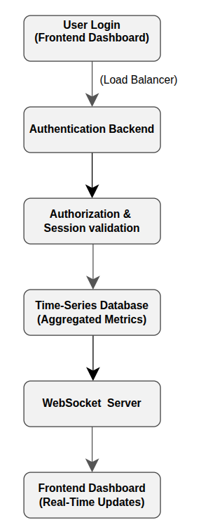
User Authentication
Users access the dashboard and authenticate through the frontend. Authentication requests are routed through a load balancer to ensure reliability and scalability.
Database Querying
After successful authentication, the dashboard retrieves pre-aggregated analytics data directly from the time-series database. These metrics are generated from materialized views, enabling fast and efficient queries.
Real-Time Updates via WebSocket
To provide live analytics, the frontend establishes a persistent WebSocket connection. As new data is processed and aggregated, updates are pushed to the dashboard in real time without the need for frequent API polling.
Data Visualization
The frontend combines historical and real-time data to display charts, metrics, and analytics summaries, offering users a clear and responsive monitoring experience.

3.3.3 Summary
The data flow design separates data ingestion from data visualization, improving system scalability, performance, and maintainability. Kafka ensures reliable event processing, while materialized views and WebSocket communication enable efficient analytics and real-time user feedback.

3.4 API Design
This section explains the API structure used in the system. The backend APIs are divided into two main components: the API Cluster for data ingestion and the Authentication API for user management and dashboard access.

3.4.1 API Design Overview
The system follows a separation of concerns approach.
Different APIs are responsible for different tasks to improve scalability, security, and maintainability.

The backend consists of:
- API Cluster: responsible only for receiving analytics events
- Authentication API: responsible for user authentication, authorization, dashboard access, and WebSocket communication
All APIs are stateless and deployed behind a load balancer.

3.4.2 API Cluster (Data Ingestion API)
The API cluster is responsible for receiving analytics events from client websites and forwarding them to the streaming system.

Main Endpoint
Post /api/track

Responsibilities
- Receive analytics events from the tracking script
- Validate tracking ID and request structure
- Perform basic security and health checks
- Forward validated events to Kafka producers

Characteristics
- High-throughput and lightweight
- No direct database queries
- Horizontally scalable
- Includes health check endpoints for monitoring
This design ensures that event ingestion remains fast and reliable even under high traffic.

3.4.3 Authentication & User Management API
The Authentication APImanages user accounts, authentication, authorization, and dashboard access.

The Authentication API manages user accounts, authentication, authorization, and dashboard access.

Authentication Endpoints

Endpoint | Method | Purpose
/api/register | POST | /api/users
/api/login | POST | User login
/api/logout | POST | User logout
/api/me | GET | Retrieve user information
/api/refresh | POST | Refresh JWT token
/api/password/forgot | POST | Password recovery
/api/password/reset | POST | Reset password
/api/email/verify/{id}/{hash} | GET | Email verification
/api/admin-only | GET | Admin-only route
/api/users | GET | List user UUIDs

These endpoints secure access to the system and protect analytics data.

3.4.4 Dashboard & Analytics API
Provides analytics data to the frontend dashboard.

Endpoints
Get /api/user/{id}/analytics

Responsibilities
- Retrieve pre-aggregated analytics data from database views
- Ensure user authorization
- Serve read-only analytics results
The dashboard API does not calculate analytics in real time; instead, it reads from materialized views for efficiency.

3.4.5 WebSocket API

Purpose
The WebSocket API enables real-time updates on the dashboard.

Responsibilities
- Establish WebSocket connections after authentication
- Push live analytics updates to users
- Support real-time dashboards without polling

Testing Endpoints
GEt /api/test-broadcast
This component improves user experience by delivering instant updates.

3.4.6 System Testing & Monitoring APIs
The system includes several internal endpoints used for testing and monitoring:

Endpoint | Purpose
/api/test-clickhouse | Test database connection
/api/test-mail | Test email service
/api/test-broadcast | Test WebSocket functionality

These endpoints help ensure system reliability during development and deployment.
3.4.7 Summary
The API design follows distributed system principles by separating data ingestion from authentication and analytics access. The API Cluster focuses on performance and scalability, while the Authentication API handles security, dashboard access, and real-time communication.

CHAPTER 4 : IMPLEMENTATION & TESTING
4.1 Technologies used
The proposed system was implemented using a combination of frontend, backend, distributed systems, and data processing technologies to support real-time analytics, scalability, and reliability.

Frontend Layer
- React.js
React.js is used to develop the web-based analytics dashboard. It provides a dynamic and responsive user interface for visualizing real-time and historical analytics data.
- WebSocket Client
The frontend uses WebSocket connections to receive real-time analytics updates instantly without continuous HTTP polling.

WebSocket & Load Balancing
- WebSocket Server
Handles real-time bidirectional communication between the frontend dashboard and backend services.
- Nginx Load Balancer
Used to distribute WebSocket connections across backend services to ensure high availability and support multiple concurrent users.

Backend Layer
- Laravel (PHP)
Laravel is used as the authentication backend. It manages:
  - User registration and login
  - JWT-based authentication
  - Authorization and access control
  - WebSocket authentication
- Spring Boot (Java)
Spring Boot is used in the API Cluster for handling analytics data ingestion and processing. It provides RESTful APIs and integrates with Kafka for distributed data streaming.

Distributed Data Processing
- Apache Kafka
Kafka is used as the core event streaming platform to handle large volumes of analytics data reliably.
- Kafka Cluster with Zookeeper
Zookeeper manages Kafka brokers and ensures fault tolerance, leader election, and cluster coordination.

Database Layer
- ClickHouse (Time-Series Database)
ClickHouse is used to store analytics data efficiently. It supports high-speed inserts and fast analytical queries.
- Aggregated Tables / Materialized Views
Analytics data is aggregated at multiple time intervals (5 minutes, 1 hour, and 1 day) to optimize dashboard performance.

Data Collection Layer
- JavaScript Analytics Tracker
- A lightweight JavaScript script is embedded into client websites to collect user behavior data such as page views, clicks, scrolls, and session information.
The tracking script is included in the client website as follows:
<script
async
src="https://cdn.jsdelivr.net/gh/salahqr/Real-Time-Distributed-Analytics-Dashboard-Project@main/analytics-tracker.js"
data-endpoint="http://localhost:8080/receive_data"
data-tracking-id="USER_UNIQUE_ID_HERE"
data-batch-size="10"
data-interval="7000"
data-debug="true">
</script>
- data-endpoint: Specifies the API endpoint that receives analytics data
- data-tracking-id: Identifies the website being tracked
- data-batch-size: Number of events sent in each batch
- data-interval: Data transmission interval in milliseconds
An initialization script is also used to configure tracking:
<script>
window.analytics = window.analytics || [];
function track(){window.analytics.push(arguments);}
track('init', { trackingId: 'YOUR-ID' });
</script>
This approach allows websites to integrate analytics functionality with minimal configuration and without impacting page performance.

System Technology Summary

The integration of React, WebSocket, Laravel, Spring Boot, Kafka, ClickHouse, and a custom JavaScript tracker enables the system to function as a scalable, real-time, and distributed analytics platform.

4.2 Code structure
The project is implemented as a distributed, multi-service system, where each major component is developed, deployed, and maintained independently. This structure improves scalability, fault isolation, and team collaboration.
Each service is organized in a separate folder and repository structure, containerized using Docker, and deployed independently.

Service-Level Structure

1. Authentication Service
- Implemented as an independent backend service
- Responsible for user authentication and authorization
- Manages JWT-based access control
- Handles WebSocket authentication
- Tested independently using Postman

2. API Cluster Service
- Implemented as a separate Spring Boot project
- Organized into clearly separated packages:
  - Controller layer for receiving analytics data
  - Service layer for validation and processing logic
  - Kafka producer and consumer components
  - Configuration layer (Kafka, Redis, application settings)
- Stateless service design to support horizontal scaling
- Uses Redis for:
  - Rate limiting
  - Fast temporary data access
- Exposes endpoints for data ingestion and system health checks

3. Data Processing Logic
- Kafka producers and consumers are implemented as separate components
- Producers publish validated events to Kafka topics
- Consumers process events asynchronously and store them in ClickHouse
- This separation allows ingestion and storage to scale independently

4. Database Layer
- ClickHouse is used as a time-series analytics database
- Raw event tables store incoming data
- Aggregated tables and materialized views store precomputed analytics
- Database logic is isolated from application logic

5. Client-Side Tracker
- Implemented as a standalone JavaScript file
- Hosted via a GitHub-based CDN
- Embedded into websites using a simple <script> tag
- Responsible for collecting, batching, and sending user events

6. Containerization
- Each service includes its own Dockerfile
- Services are deployed as separate containers
- This design supports independent scaling and deployment

4. 3 Key implementation
This project includes several key implementation decisions that enable real-time analytics, scalability, and reliable data processing in a distributed environment.

1. Distributed Microservice Architecture
- Authentication, data ingestion, processing, and tracking are separated into independent services
- Services communicate through well-defined APIs and message queues
- Failure in one service does not halt the entire system

2. Event-Based Data Collection
- User interactions are collected as events
- Events can be sent individually or in batches
- Data is transmitted at fixed intervals (every 6 seconds) to reduce network overhead

3. Kafka-Based Streaming Pipeline
- Kafka is used as the central message broker
- API Cluster acts as both:
  - Producer (publishing events)
  - Consumer (processing events)
- Kafka decouples data ingestion from storage and analysis

4. High-Performance Analytics with ClickHouse
- ClickHouse is used for high-throughput event storage
- Raw events are stored without heavy computation
- Aggregated analytics are precomputed using materialized views
- Analytics are calculated for multiple time windows (5 minutes, 1 hour, 1 day)

5. Redis-Based Rate Limiting
- Redis is used to enforce rate limits on incoming requests
- Prevents abuse and protects the API cluster from overload
- Improves system stability under high traffic

6. Real-Time Dashboard Updates
- WebSockets are used to push real-time updates to the frontend
- Authentication is validated before opening WebSocket connections
- Enables live analytics without frequent polling

7. Containerized Deployment
- Each service is deployed in its own container
- Enables consistent environments across development and production
- Supports future orchestration and scaling
4. 4 Testing strategy
This project adopts a multi-level testing strategy to ensure the correctness, reliability, and scalability of the distributed analytics system. Testing was focused primarily on the backend services, data pipeline, and database layer, which represent the core functionality of the system.

1. Unit Testing
Unit testing was applied to validate individual components in isolation.

Database Unit Tests
- Insert operations into ClickHouse tables were tested using sample event data
- Data types, default values, and timestamp accuracy were verified.
- Aggregation queries and materialized views were tested to ensure correct computation for:
  - Page views
  - Session duration
  - Bounce rate
  - User counts

Kafka Producer Validation
- Sample events were produced to Kafka topics.
- Message format and serialization were verified before sending.
- Error handling for invalid or missing fields was tested.

2. Integration Testing
Integration testing was conducted to verify communication between system components.

API to Kafka Integration
- The /receive_data endpoint was tested to ensure:
  - Incoming events are validated
  - Events are successfully published to Kafka topics
- Invalid requests were tested to confirm proper rejection.

Kafka to ClickHouse Integration
- Kafka consumers were tested to ensure:
  - Messages are correctly consumed
  - Events are stored in ClickHouse without data loss
- End-to-end data flow from API → Kafka → Database was verified.

3. API Testing
API endpoints were tested using Postman.

Tested Scenarios:
- Event ingestion via /receive_data
- Authentication-related endpoints (login, register) for request validation
- Health-check endpoints to verify service availability
Each test validated:
- HTTP status codes
- Request/response structure
- Error handling behavior

4. System Testing
System-level testing was performed to ensure the system functions correctly as a whole.
- JavaScript tracker was embedded in a test HTML page.
- Events were generated (page views, clicks, scrolls).
- Real-time data arrival was verified in ClickHouse.
- Aggregated analytics results were validated using summary tables.

5. Testing Summary
The testing strategy ensured:
- Data correctness at each processing stage
- Reliable communication between distributed components
- Stability of the analytics pipeline under continuous data ingestion
This approach provides confidence in the system’s correctness and readiness for real-world usage.

CHAPTER 5 :FUTURE WORK
This chapter discusses possible enhancements and extensions that can be applied to the system in future versions. While the current implementation successfully delivers real-time data collection, processing, and visualization, several improvements can further increase reliability, scalability, and usability.

5.1 Scalability and Performance Enhancement
Future work may focus on improving system scalability to handle higher traffic volumes and larger numbers of concurrent users. This includes optimizing Kafka topic partitioning, improving consumer parallelism, and tuning database performance for high ingestion rates.

5.2 Advanced Monitoring and Observability
Currently, system monitoring is limited to basic logging and testing. Future enhancements may introduce centralized monitoring and alerting mechanisms to track system health, detect failures, and measure latency across different system components.

5.3 Load and Stress Testing
Although the system was functionally tested, future work may include comprehensive load and stress testing to evaluate system behavior under peak traffic conditions. This would help identify performance bottlenecks and ensure system stability at scale.

5.4 Data Retention and Optimization Strategies
Future versions of the system may implement data lifecycle management policies, such as automatic data expiration, tiered storage, or archiving mechanisms, to optimize storage usage and long-term performance.

5.5 Enhanced Analytics Capabilities
The analytics layer can be extended to support more advanced metrics, customizable aggregation intervals, and additional analytical views. This would allow the system to serve a wider range of analytical use cases without changing the core data collection pipeline.

5.6 Security and Access Control Improvements
Future work may enhance security by introducing more fine-grained access control, improved authentication mechanisms, and better protection against unauthorized data access.

Chapter Summary
The proposed future enhancements aim to strengthen system robustness, scalability, and analytical flexibility. These improvements can be implemented incrementally without significant changes to the existing system architecture.

REFERENCES
- ClickHouse Documentation.
Available at: https://clickhouse.com/docs
- Apache Kafka Documentation.
Available at: https://kafka.apache.org/documentation/
- Apache ZooKeeper Documentation.
Available at: https://zookeeper.apache.org/documentation.html
- Spring Boot Reference Guide.
Available at: https://docs.spring.io/spring-boot/docs/current/reference/html/
- React Official Documentation.
Available at: https://react.dev
- Laravel PHP Framework Documentation.
Available at: https://laravel.com/docs
- MDN Web Docs – JavaScript and Web APIs.
Available at: https://developer.mozilla.org
- Donne Martin, System Design Primer.
Available at: https://github.com/donnemartin/system-design-primer
- Kafka Architecture and Event Streaming Concepts – Online Video Tutorials.
Available on YouTube.
- Spring Boot REST API Development – Online Video Tutorials.
Available on YouTube.

